Senior Citizens use of Social Media in Waterloo: A Qualitative Study

Justin A. Example
Department of Psychology, Wilfrid Laurier University
PS398: Qualitative Methods in Psychology
Dr. Livia Dittmer
November 15, 2022

Introduction
This document follows the writing conventions of the American Psychological Association (APA) 7th Edition. You can edit this document as you explore it. It was created in Windows 10 using the Microsoft Word desktop application. Word has a lot of features that are very helpful for writing.

Word Processors

Microsoft Word for Windows and Mac
Microsoft Word is available on Windows and Mac. The should have most of the features described here. Using Mac’s Word with VoiceOver may have some bugs and so working with word processor for MacOS, Pages, may be better.

Pages for MacOS

Google Docs
The more students know about the features built into word processors, the easier it is to do essays or thesis. Learning to use a word processor is a life-long skill to have. I learned to use it through a librarian when I was a grad student and I also learned cool techniques by working with a blind scholar.

Styles and Word Processors
Do you want make writing a little easier? If so, then it’s worth learning about the styles feature of your word processor. Styles are a set of attributes about text, such as font size, bolding, line spacing, indent, etc. We can create styles with APA requirements and then easily apply that style to text in our essay.
Styles are a feature of many word processors, although there may be important differences. I’ve tried to describe how to use styles in common word processors used by students. If I missed yours, please email me, mweiler@wlu.ca.

Microsoft Word: Styles Gallery
The styles gallery in Microsoft Word lists all available in the Home tab.
I made a series of styles that match the APA requirements for a basic student essay. For example, I created a style for generic paragraphs, heading levels 1 through 5, and reference items in the reference list.
To give your text proper style, put the cursor on the text you want to modify, then select the style from the Style Gallery that you want applied. There are different ways you can select the style

Using the Mouse to Select a Style. You can use the mouse to go to the
Figure 1
The Home Tab in Word for Windows contains the Style Gallery
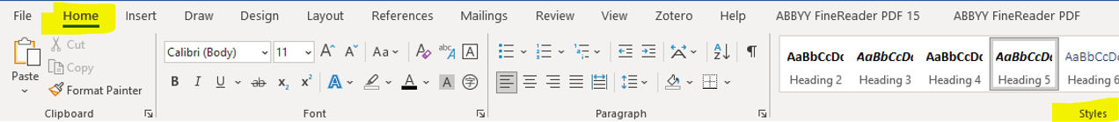

The Home Tab contains the Styles group where you will find the Styles table. This table contains buttons of the available styles that can be applied to the essay.
Figure 2
Styles Gallery in Word for Windows (desktop app)
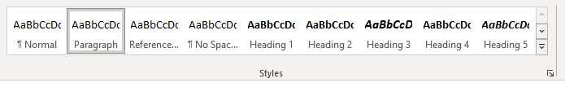

Using the Keyboard to Select a Style. You can use the mouse to go to the Styles Gallery or, if you are using Microsoft Word’s desktop app, you can use shortcut keys by pressing ALT then the H key, then the L key. This moves the keyboard focus to the Home Tab, Styles Group, and into the Styles Table. You can then use the arrow keys to move around the style options.
Figure 3
The access keys appear on the user interface after pressing the ALT key
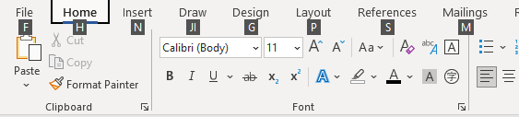
Note. Access keys are a way of navigating an interface by just using the keyboard. In Word (desktop) for Windows, press the ALT key will bring up letter icons showing a letter or letters that will move the keyboard focus or activate a user interface element.

Google Docs: Styles Popup List
Google Docs can use most of the styles in the document I provided.
Figure 4
The styles popup list in Google Docs
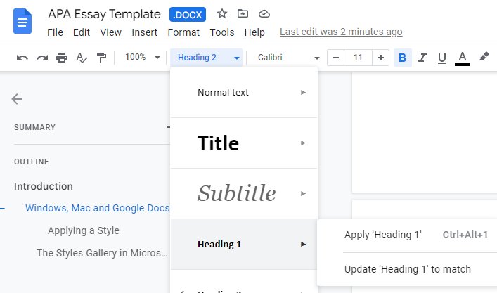
The Styles Popup menu in Google Docs lists many styles available in the APA Essay Template. However, Google Docs does not show all the styles I’ve created (e.g., paragraph, reference entry). If you use Google Docs, you will have to apply the style choices manually.

MacOS and Pages

Inserting Page Numbers
According to the APA manual of style, for student essays, page numbers are to appear on all pages. The numbering starts with 1 and they are in the top right of the page header. The page header is a region at the top of each page.
Figure 5
The page header contains the page number
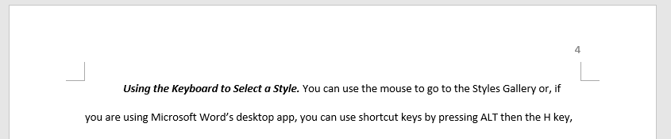

Microsoft Word: Adding Page Numbers

Google Docs: Adding Page Numbers

MacOS and Pages: Adding Page Numbers

References
Dunlop, J. M., Chechak, D., Hanby, W., & Holosko, M. J. (2020). Digital Learning in Rural Ontario, Canada: An Evaluation of the Computer for Seniors Program. Journal of Rural and Community Development, 15(4), 24–38. https://journals.brandonu.ca/jrcd/article/view/1795
Gangneux, J. (2019). Rethinking social media for qualitative research: The use of Facebook Activity Logs and Search History in interview settings. The Sociological Review, 67(6), 1249–1264. https://doi.org/10.1177/0038026119859742
Lunnay, B., Borlagdan, J., McNaughton, D., & Ward, P. (2015). Ethical Use of Social Media to Facilitate Qualitative Research. Qualitative Health Research, 25(1), 99–109. https://doi.org/10.1177/1049732314549031

